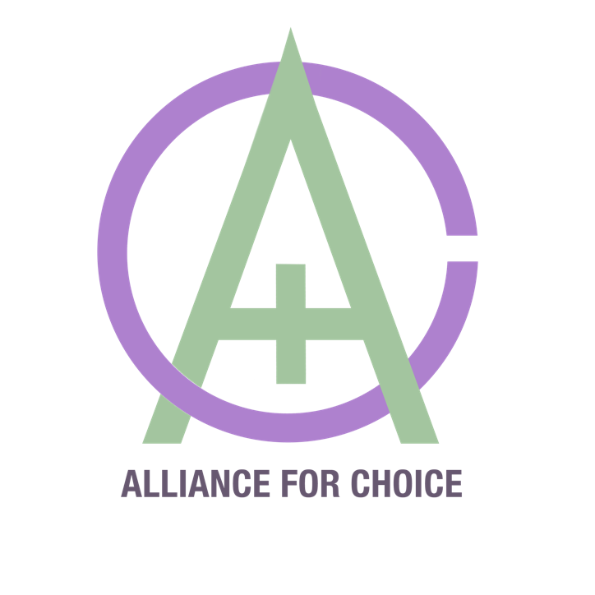

Submission to the Department of Justice and Equality on the Operation of Part 4 of the Criminal Law (Sexual Offences) Act 2017

Alliance for Choice

September 2020

www.alliance4choice.com
alliancechoice4@gmail.com
Alliance for Choice is a pro-choice organisation that believes everyone who needs an abortion should have free, safe and legal access in their own country, without stigma; set up in 1996, we free, safe and legal abortion access in Northern Ireland campaign for an end to the criminalisation of women and pregnant people and an end to the harassment of people using or providing reproductive health services. We work alongside our sister organisation in Ireland, the Abortion Rights Campaign (ARC).

We have read the ARC submission to the Review Commission and wholly support their recommendations that consensual sex work between adults is decriminalised, and that current sex workers are included in the review process.
We would take this opportunity to share findings from the recent review of similar law in NI commissioned by the NI Department of Justice. This review found a dramatic increase in violence against sex workers since the introduction of criminalisation of payment for sexual services. The review highlighted that sex workers have informally reported more violent crimes since the introduction of the legislation: the number of reported assaults increased from 3 to 13, sexual assaults from 1 to 13, and threatening behaviour from 10 to 42. In addition, the review found that “sex workers are exposed to higher rates of anti-social and nuisance behaviour” and “sex workers reported higher levels of anxiety and unease, and increased stigmatisation.”
Similar to the 2015 law in NI, the 2017 Act did not truly decriminalise sex work. It remains an offence in both jurisdictions for sex workers to work together from the same premises, a common harm reduction measure used by sex workers. The Irish Human Rights and Equality Commission voiced concern that the definition of brothel keeping places sex workers “in greater danger as they may opt to work alone despite the risks involved.”
The 2017 law has resulted in more sex workers being charged than clients, and has been disproportionately enforced against migrant sex workers. Criminalisation of paying for consensual sexual services creates greater levels of stigma for sex workers, which is a barrier when accessing support services and healthcare. Additionally, the criminality reduces third party reporting in relation to trafficking, exacerbating the issue rather than addressing it.

As a pro-choice organisation, we believe bodily autonomy extends to all aspects of a person’s self, including consensual adult sex work. We recommend that the government fully decriminalises all aspects of consensual sex work and engages directly with Sex Workers Alliance Ireland as representatives of current sex workers, and as the experts in the impact of this law. When we ask ourselves and ask of you, “what is the law for?” we expect the answer to be to protect sex workers and trafficked people, currently the law does neither and in fact jeopardises both the safety of sex workers and the information gathering for trafficking. It is up to the Department of Justice and Equality to make the best decision for the protection of rights based on best evidence, rather than based on social mores.

Northern Ireland Department of Justice, “Assessment of Review of Operation of Article 64A of the Sexual Offences Order (Northern Ireland) 2008: Offence of Purchasing Sexual Services,” September 2019, https://www.justice-ni.gov.uk/sites/default/files/publications/justice/assessment-of-impact-criminalisation-of-purchasing-sexual-services.pdf.
Northern Ireland Department of Justice, “Assessment of Review of Operation of Article 64A of the Sexual Offences Order (Northern Ireland) 2008: Offence of Purchasing Sexual Services,” September 2019, https://www.justice-ni.gov.uk/sites/default/files/publications/justice/assessment-of-impact-criminalisation-of-purchasing-sexual-services.pdf.
Irish Human Rights and Equality Commission, “Ireland and the Convention on the Elimination of Racial Discrimination: Submission to the United Nations Committee on the Elimination of Racial Discrimination on Ireland’s Combined 5th to 9th Report,” October 2019, https://www.ihrec.ie/app/uploads/2019/11/IHREC_CERD_UN_Submission_Oct_19.pdf.
Sarah Burns, “Gardaí Contact 38 People Suspected of Buying Sexual Services,” The Irish Times, September 27, 2019, https://www.irishtimes.com/news/crime-and-law/garda%C3%AD-contact-38-people-suspected-of-buying-sexual-services-1.4032275.
Gordon Deegan, “Justice Minister Confirms 10 out of 18 Charged with Brothel-Keeping Are Romanian,” Irish Examiner, December 5, 2019, sec. IE-Main/NEWS, https://www.irishexaminer.com/news/arid-30968679.html.

